**Task 4: Grid-Connected PV Plant Performance [10 marks]**

**Objective**: Analyse the monthly energy output of the designed PV system and evaluate the impact of temperature.

a) Monthly Energy Output:

* Use PVGIS to estimate the monthly energy output (in kWh) for the grid-connected PV system designed in Task 1.
* Present the results in a table or graph, showing energy output for each month.
* Installed Peak PV Power = 42.84kWp
* Yearly PV Energy Production =60142.15kWh
* Estimated System Losses = 14%
* Slope of mounted PV grid(opt) = 4 $°$
* Azimuth of PV grid = 0 $°$

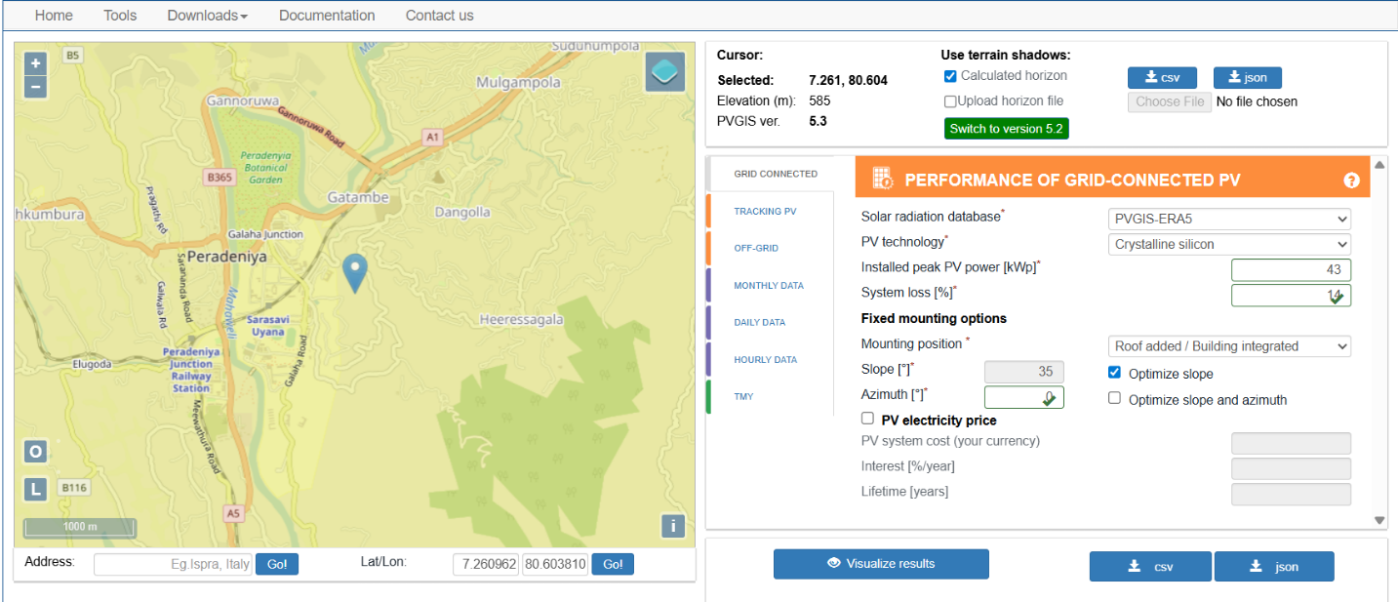

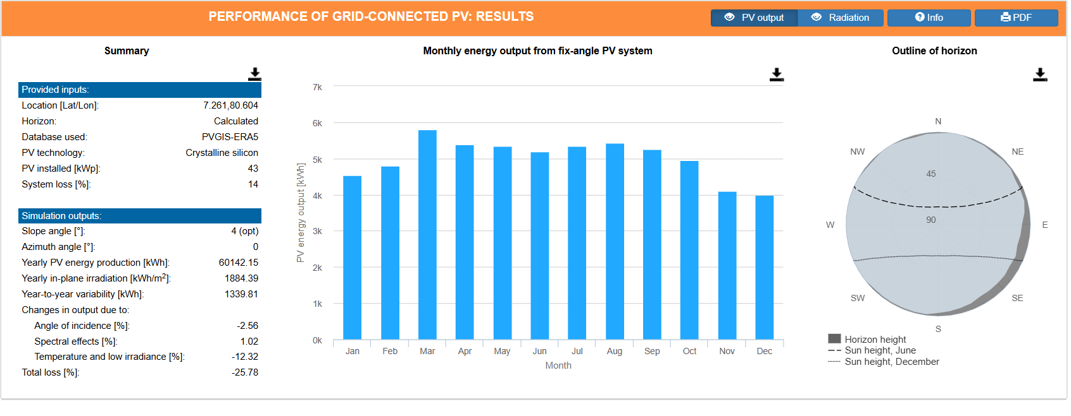FIGURE XX

FIGURE XX

TABLE XX

|  |  |
| --- | --- |
| **Month** | **Energy Output (kWh)** |
| January | 4545.59 |
| February | 4800.60 |
| March | 5798.56 |
| April | 5378.38 |
| May | 5352.45 |
| June | 5180.25 |
| July | 5342.04 |
| August | 5439.89 |
| September | 5259.51 |
| October | 4942.86 |
| November | 4105.70 |
| December | 3990.31 |

b)Temperature Impact:

* Obtain monthly average ambient temperatures for the hostel’s location using PVGIS or a reliable weather database.
* Compare the monthly PV energy output with the corresponding average temperature.
* Discuss the effect of cell temperature on PV panel efficiency and power output, referencing the temperature coefficient of the selected panels (typically -0.3% to -0.5% per °C above 25°C).

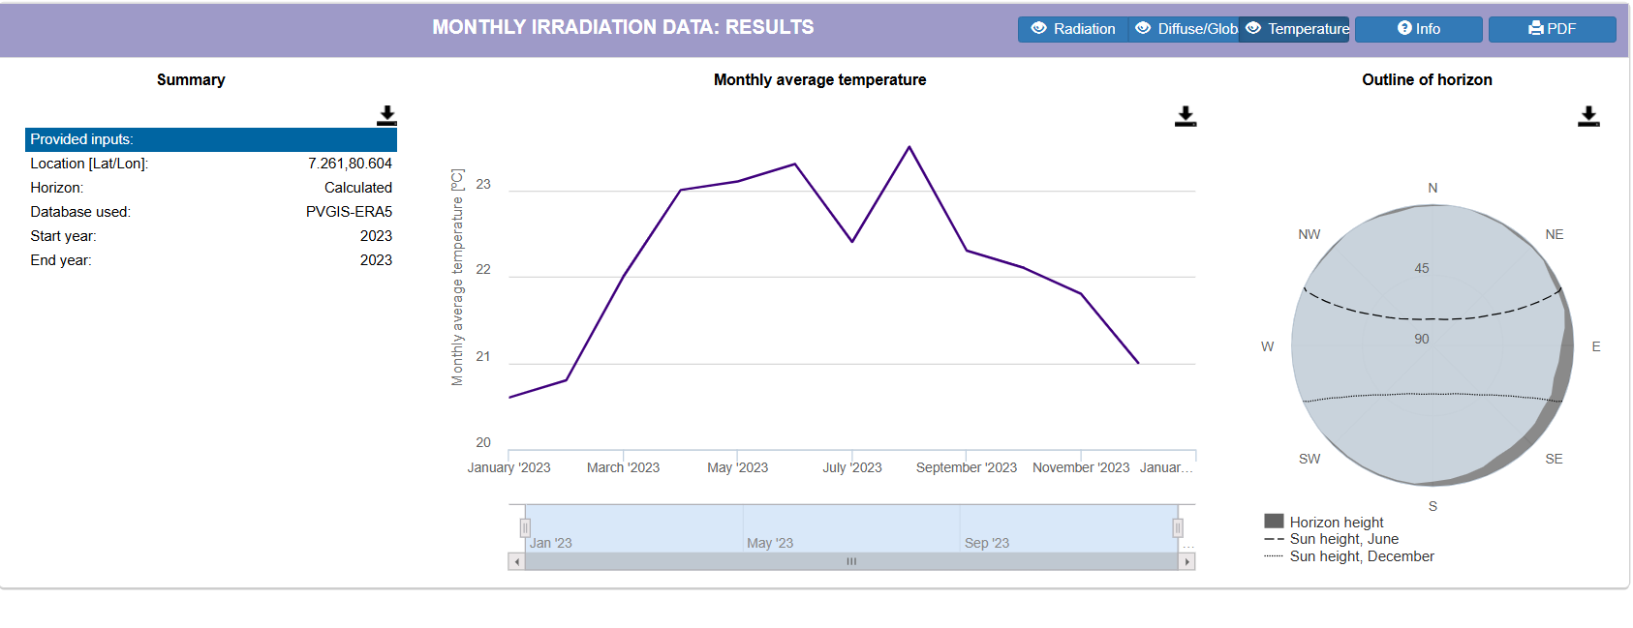FIGURE XX

TABLE XX

|  |  |
| --- | --- |
| **Month** | **Average Ambient Temperature ($℃$)** |
| January | 20.6 |
| February | 20.8 |
| March | 22.0 |
| April | 23.0 |
| May | 23.1 |
| June | 23.3 |
| July | 22.4 |
| August | 23.5 |
| September | 22.3 |
| October | 22.1 |
| November | 21.8 |
| December | 21.0 |

**(b) Temperature Impact, Comparison with Energy Output and effect of cell temperature on PV panel efficiency and power output**

The monthly PV energy output generally mirrors the seasonal variation in solar irradiance, with the highest production occurring in March (5,798.56 kWh) and consistently high values from April through August. In contrast, the lowest outputs are observed in November (4,105.70 kWh) and December (3,990.31 kWh), reflecting reduced sunlight availability. When compared with the corresponding monthly average ambient temperatures, it is evident that warmer months (≈23–23.5 °C) tend to align with higher electricity generation due to greater solar resource availability, though the influence of higher temperature partially offsets the gain. Cooler months such as January and December exhibit lower generation, which is mainly attributable to limited solar radiation rather than temperature effects.

The influence of temperature becomes more evident when considering PV cell operating conditions. Since module temperature rises above ambient values under direct sunlight, cell operating temperatures in hot months can reach 42–44 °C. This is significantly higher than the standard test condition of 25 °C, and because crystalline silicon panels typically exhibit a temperature coefficient between –0.3% and –0.5% per °C, such heating results in an efficiency loss of approximately 6–8% of rated output. For instance, at 45 °C cell temperature, power output can decrease by nearly 7.5%, which explains the slight reduction in expected yield despite high solar irradiance during peak summer.

Thus, while solar irradiance remains the dominant factor in determining monthly PV production, elevated cell temperatures consistently impose a performance penalty. These losses highlight the importance of considering temperature effects in both system design and yield prediction, as they contribute to seasonal fluctuations and reduce overall energy harvesting efficiency.

**C) Analysis:**

**• Explain how temperature variations influence the system’s performance and suggest design considerations (e.g., ventilation, panel type) to mitigate efficiency losses.**

Temperature variations have a direct influence on PV system performance through their effect on the electrical characteristics of the modules. As cell temperature increases, the open-circuit voltage decreases more significantly than the small rise in short-circuit current, leading to a reduction in maximum power output. For crystalline silicon panels, this effect is quantified by the negative temperature coefficient of power (–0.3% to –0.5%/°C above 25 °C). At the studied site, where ambient temperatures of 20–23.5 °C translate into estimated cell operating temperatures of 41–44 °C, the system experiences a consistent 6–8% loss in energy yield compared to standard test conditions. This makes temperature one of the most important secondary factors, after irradiance, in determining real-world performance.

To minimize these losses, system design should include passive thermal management strategies such as allowing adequate air circulation behind panels, maintaining sufficient tilt and spacing for ventilation, and avoiding roof-integrated systems that trap heat. Module selection is another key factor: technologies with lower temperature coefficients (e.g., thin-film or heterojunction) reduce thermal losses, while higher-efficiency crystalline silicon modules also help by reducing overall array size and heat buildup. Good inverter placement in shaded and ventilated locations further improves system reliability in hot conditions.

More advanced options include active cooling, hybrid photovoltaic–thermal (PVT) collectors that harvest waste heat, and the use of distributed power electronics such as DC optimizers or microinverters to mitigate local hot-spot effects. However, these measures are usually more costly and are best considered in large-scale or high-value applications. For most rooftop and medium-scale systems, low-cost passive measures and careful module selection provide the best trade-off between cost and performance. Therefore, by addressing temperature effects through ventilation, technology choice, and optimized layout, the long-term efficiency and energy yield of the PV system can be significantly improved